
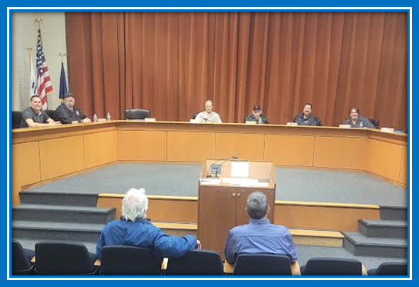
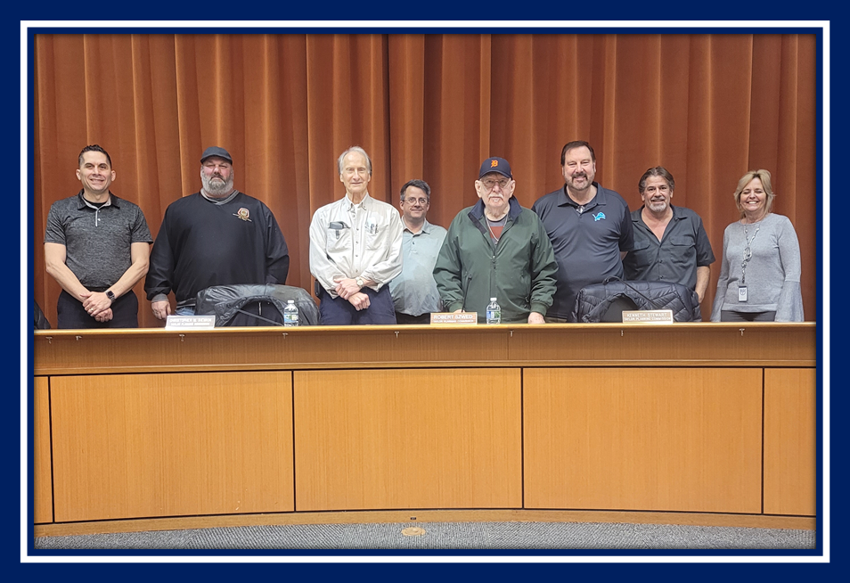
City of Taylor Planning Commission
Annual Report 2023-2024
Lora Fell, Director
Susan Riddle, Department Manager
Email: lfell@ci.taylor.mi.us

-2022
Table of Contents
CITY OF TAYLOR PLANNING COMMISSION --------------------------------------------3
Background --------------------------------------------------------------------------------3
2023-2024 Planning Commission ----------------------------------------------------3
Report in Brief------------------------------------------------------------------------------3
Planning Commission Operations ----------------------------------------------------3
Current Re-development -------------------------------------------------------------------------5
Remodels ------------------------------------------------------------------------------------------5-8
New Builds --------------------------------------------------------------------------------------9-10
Stats ----------------------------------------------------------------------------------------------11-12
Van Born Overlay----------------------------------------------------------------------------------13
Taylor Midtown--------------------------------------------------------------------------------------14
Recommendation & Summary ------------------------------------------------------------------14-15

CITY OF TAYLOR pLANNING COMMISSION

Background
The City of Taylor Planning Commission is governed by the Michigan Planning Enabling Act, State of Michigan Public Act 33 of 2008, as amended, and by the City of Taylor’s Zoning Ordinance.

2022-2023 Planning Commission
Mayor Timothy Woolley
Robert Szwed, Chairman
Kenneth Stewart, Vice Chairman
Christopher M. Siemion, Secretary
Charley Johnson, City Council Representative
Bill Fisher
Fadi Ghallozi
Mark Styles

Report in Brief
- Operations of the Planning Commission
- Status of current planning activities
- Development Highlights
- Recommendations to City Council relating to planning and development
- Summary

Planning Commission Operations
The City of Taylor Planning Commission held nineteen (19) meetings, in the 2023/2024 year. During the last fiscal year there were thirty-six (36) site plans reviewed, twelve (12) Special Land Uses, five (5) property Re-zonings, the yearly CIP (Capital Improvement Plan), four (4) Ordinance text amendments and the Planning Commission report. Four (4) projects were administratively reviewed and approved. The Planning Department received over 168 new business applications (re-occupancies into existing buildings). The Planning Commission and Planning Department have considered and approved, or made recommendations to City Council on total of over two-hundred and thirty-one (231) new development projects in the city.
The Planning Department reviewed over 1,800 building permits and performed over 250 exterior site inspections for new businesses over the past year.
The City of Taylor’s Planning Commission has worked with dedication to their duties and moved new development forward. The number of new business startups and re-development, remains to be on an upsurge.
In addition to the normal planning activities, the Planning Commission has continued its involvement, review and approval of the new Marihuana Ordinances and regulations. Also, the review and approval of the Van Born Road Gateway Overlay Plan. This plan’s goal is to revitalize the Van Born area through upgraded development requirements to improve the visual character and provide support for a pedestrian friendly district. This is a joint venture with Dearborn Heights, to promote revitalization along both sides of Van Born Road. The Planning Department is also working on the revisions to the Taylor Midtown Corridor Plan and the ongoing Eureka Way plan.
2023-2024 Planning Activity

Administrative Plan Reviews | 4
PC Plan Reviews | 48
Re-occupancy Reviews (New Businesses going into existing buildings) | 168
Capital Improvements Plan | 1
Planning Commission Report to City Council | 1
Recommendations to City Council | 5
Total Planning Activity July 2023 - June 2024 | 227 Projects

HIGHLIGHTS
New Re-development
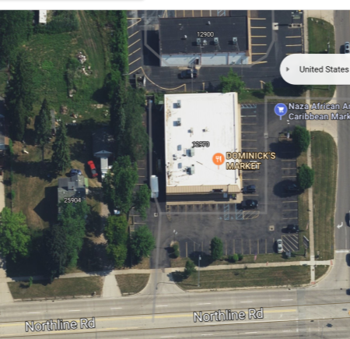
DOMINICK’S GAS & CONVENIENCE

NWC BEECH DALY & NORTHLINE
BEFORE
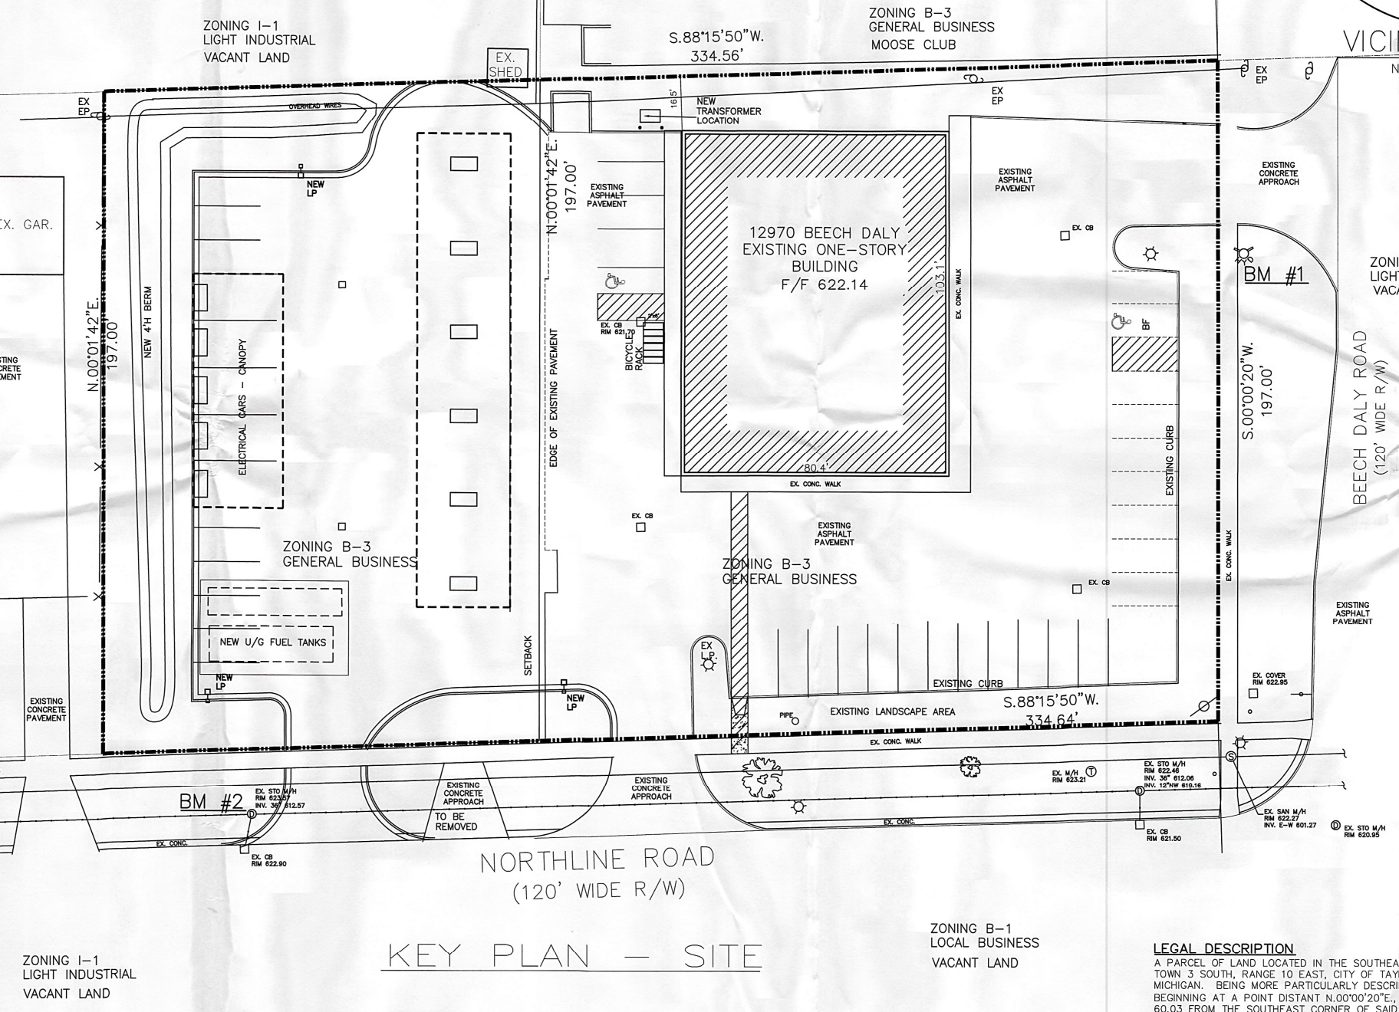

APPROVED TO BUILD

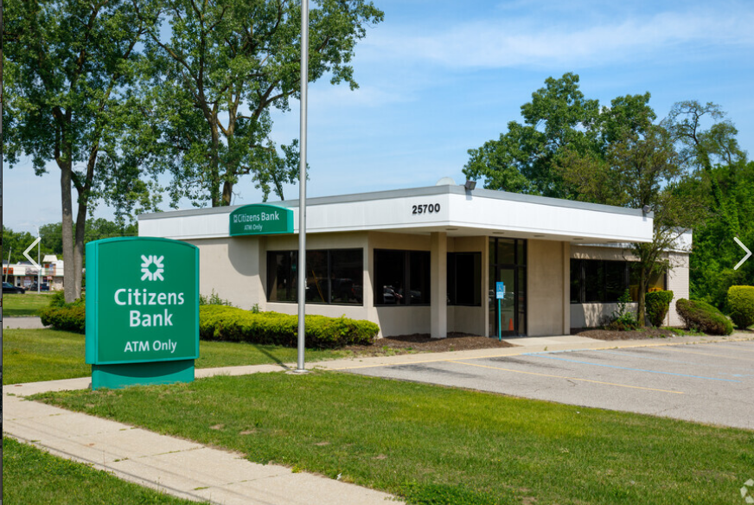
BEFORE

PC Approved to renovate & reutilize former bank at
25700 Goddard.

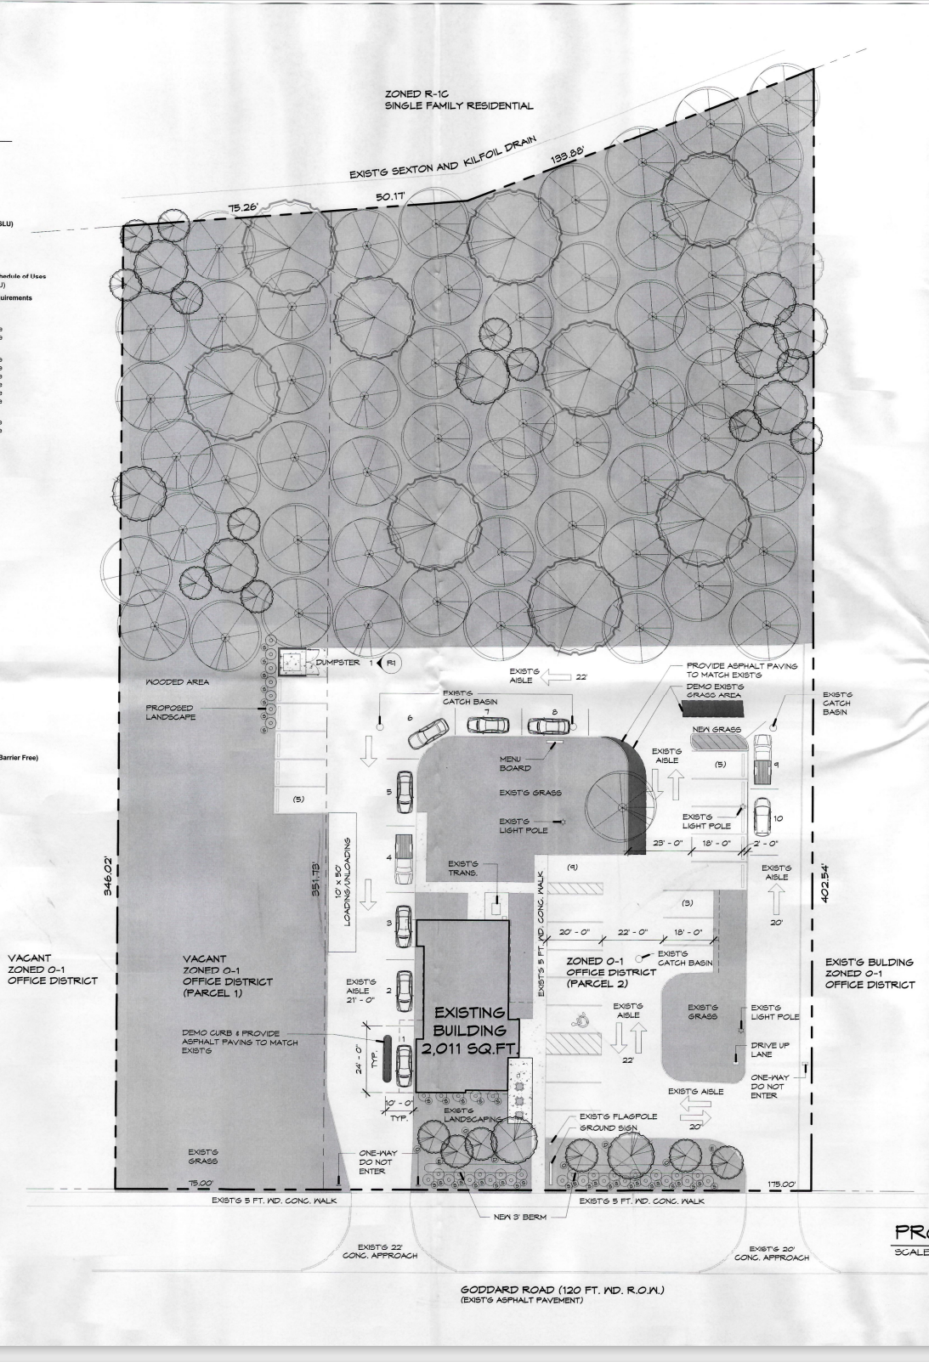



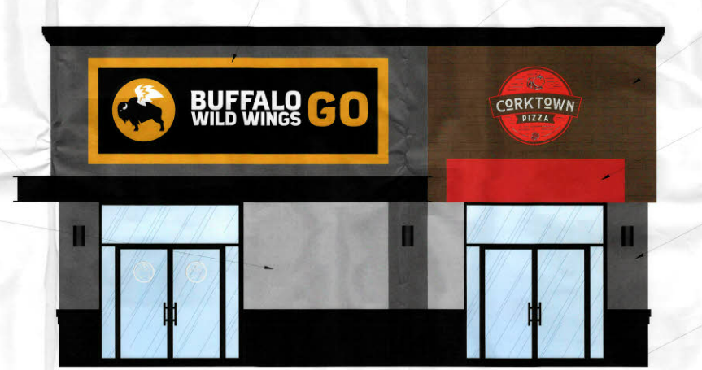
Former Huntington Bank at 9895 Telegraph converted to– New BWW to go and new tenant space
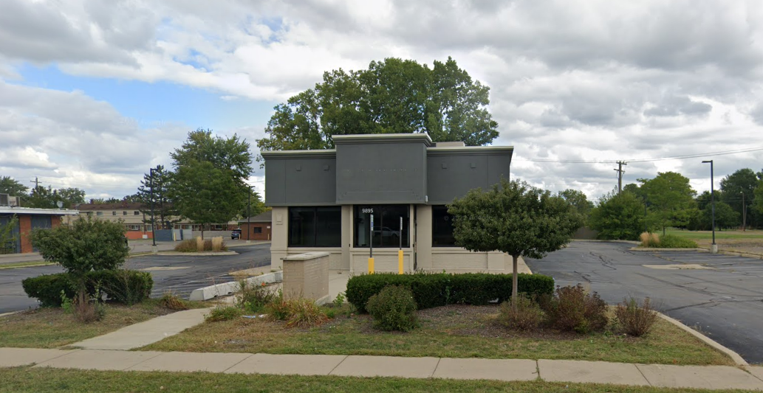

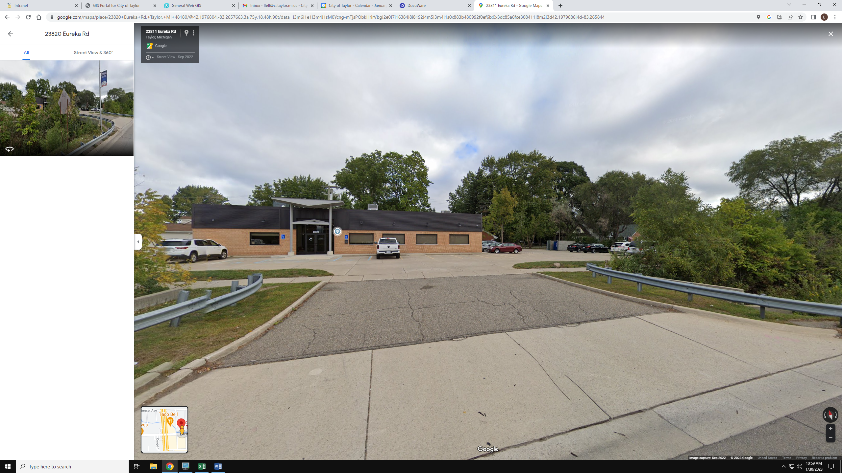

3,333 sq. ft. addition to Law Office at 23820 Eureka
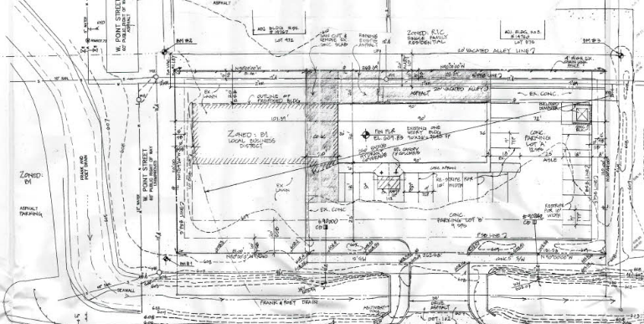

Former WOW Gas & Convenience
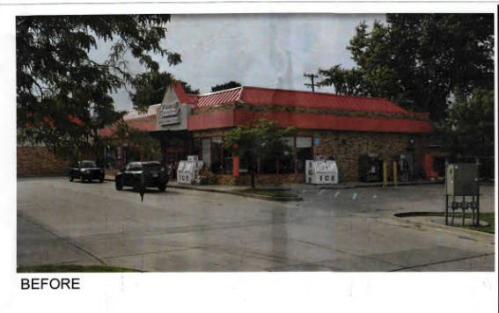

New Marathon Gas & Convenience at at Ecorse & Banner

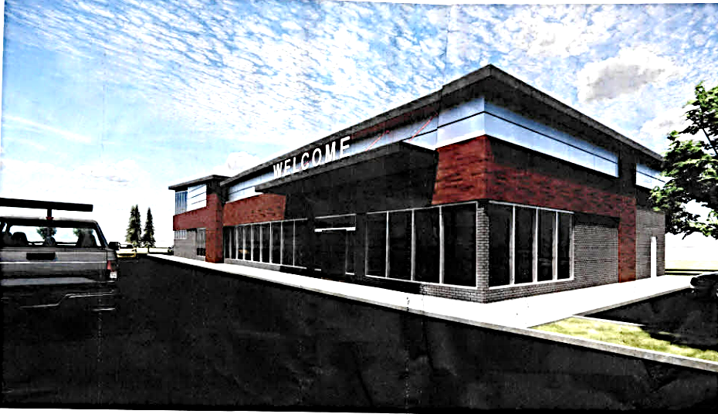
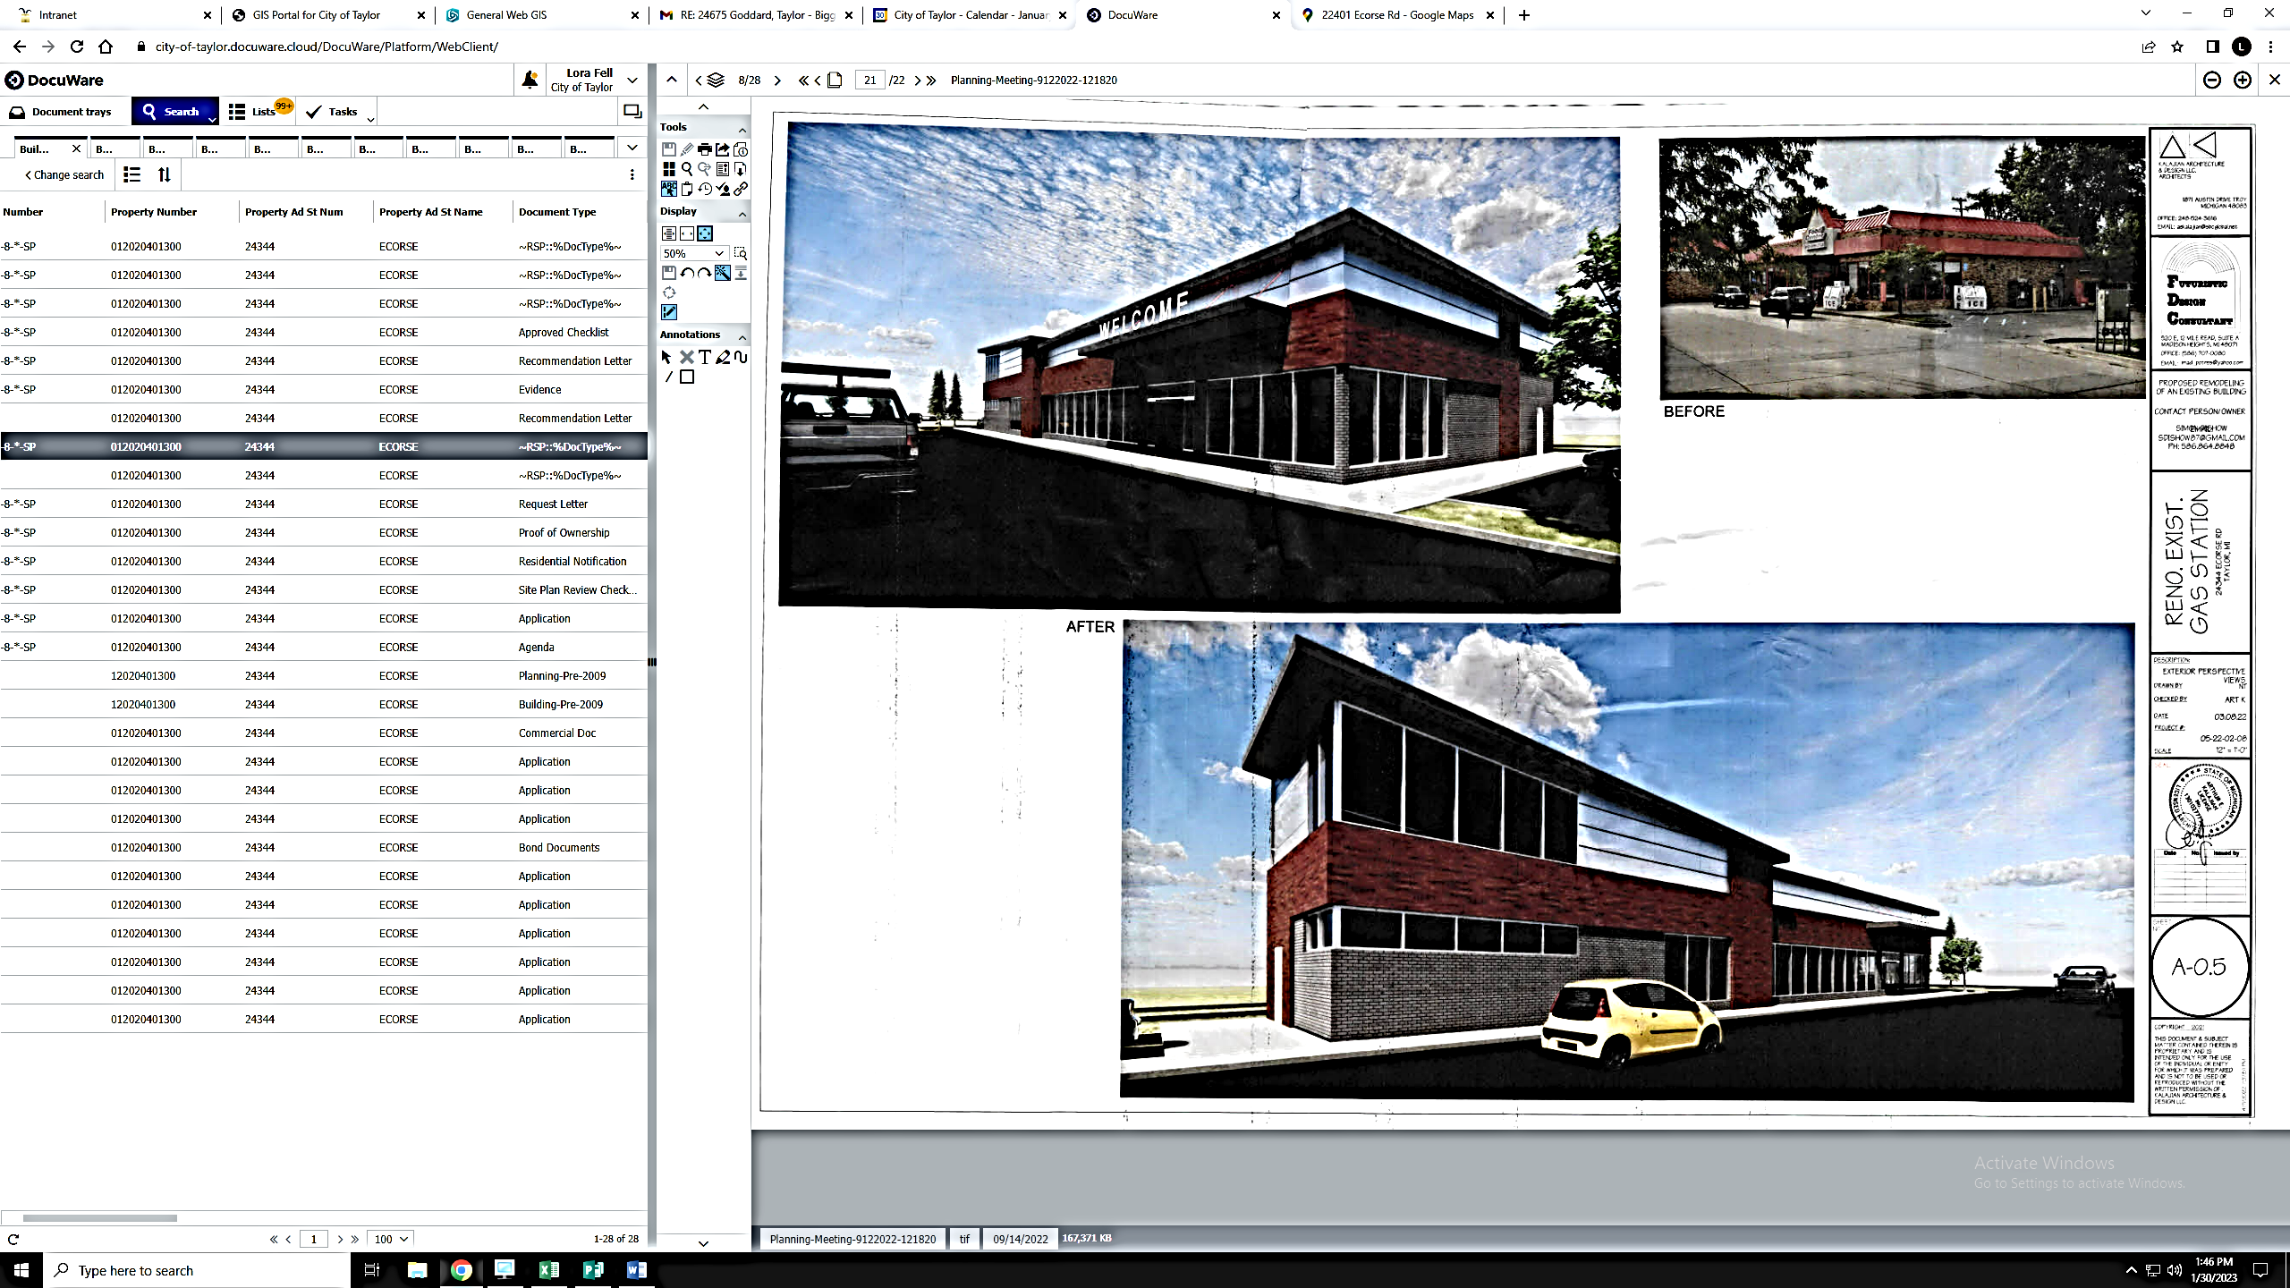

NEW DEVELOPMENT
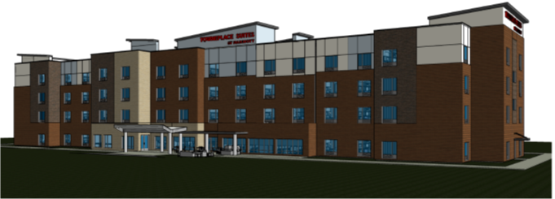
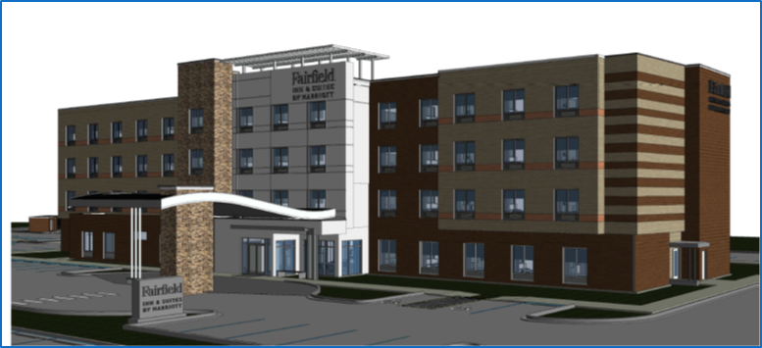
Taylor’s two new hotels are now open for guests. Fairfield Inn & Town Place Suites are located on the north side of Eureka, just east of I-75.

New Chick-Fil-A at 22250 Eureka- in front of Southland Mall
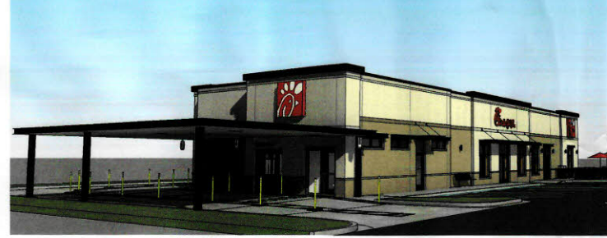

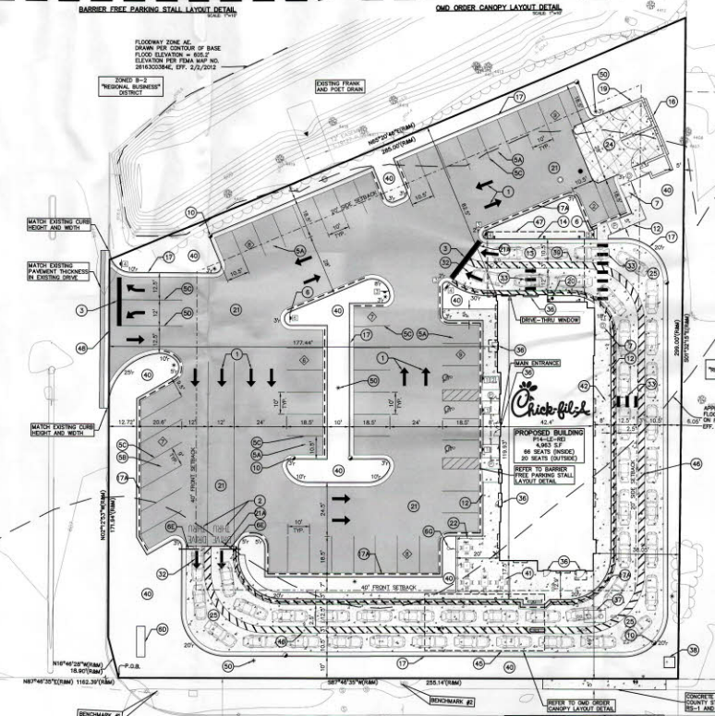

New Taco Bell at 27330 Eureka – in front of Cambridge Square
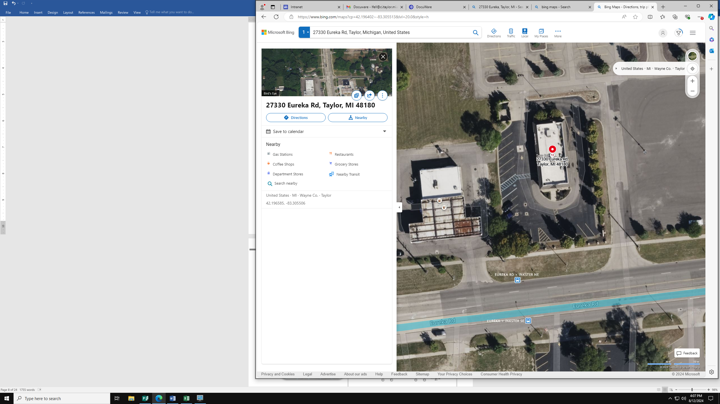


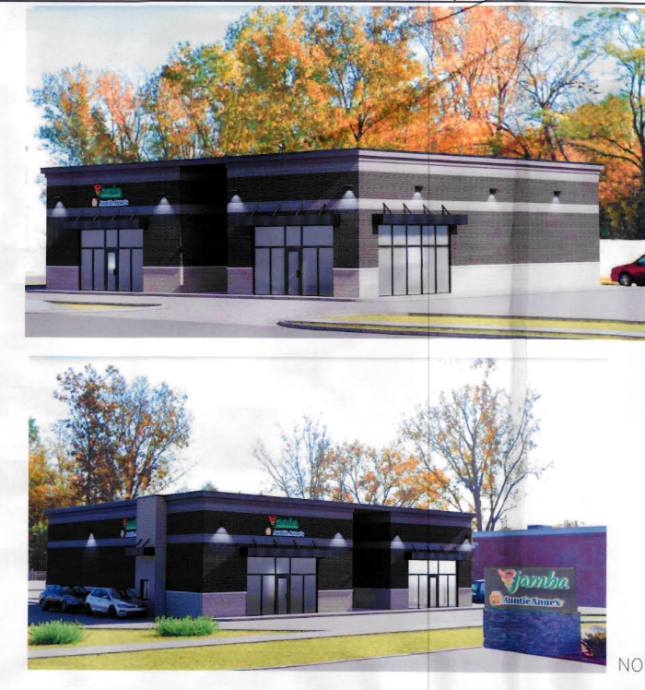
Jamba Juice & Aunt Annie’s – approved to build at 7815 Telegraph
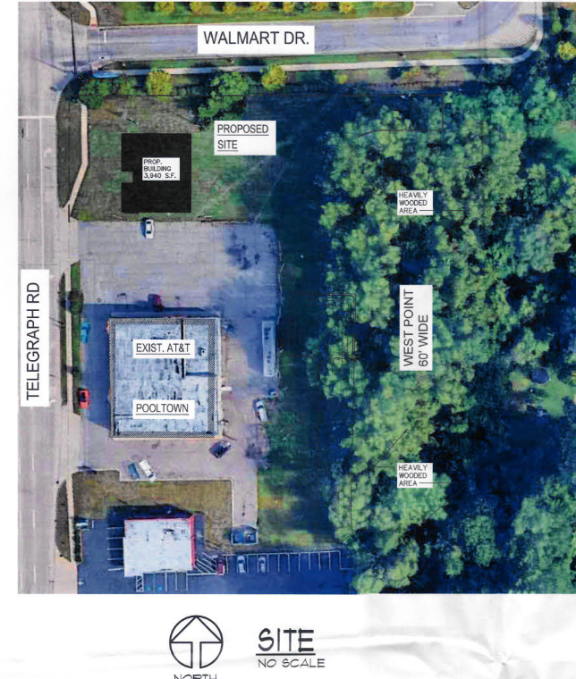

The number of new commercial businesses building, reoccupying and renovating existing sites is up by 9% from last year. Commercial and residential re-development is currently surging, with many new businesses looking to develop in Taylor, many choosing to re-develop and remain in Taylor, and more residents looking to make Taylor home.

Eureka continues to lead in the most commercial development, with Telegraph and Goddard coming in a close second in new development.

VAN BORN OVERLAY DISTRICT
This project is now a reality, as a joint effort between Taylor and Dearborn Heights to spark improvements to the streetscape, business appearance and overall aesthetics of Van Born Road, resulting in attacting new businesses and a safer more pedestrian friendly environment.
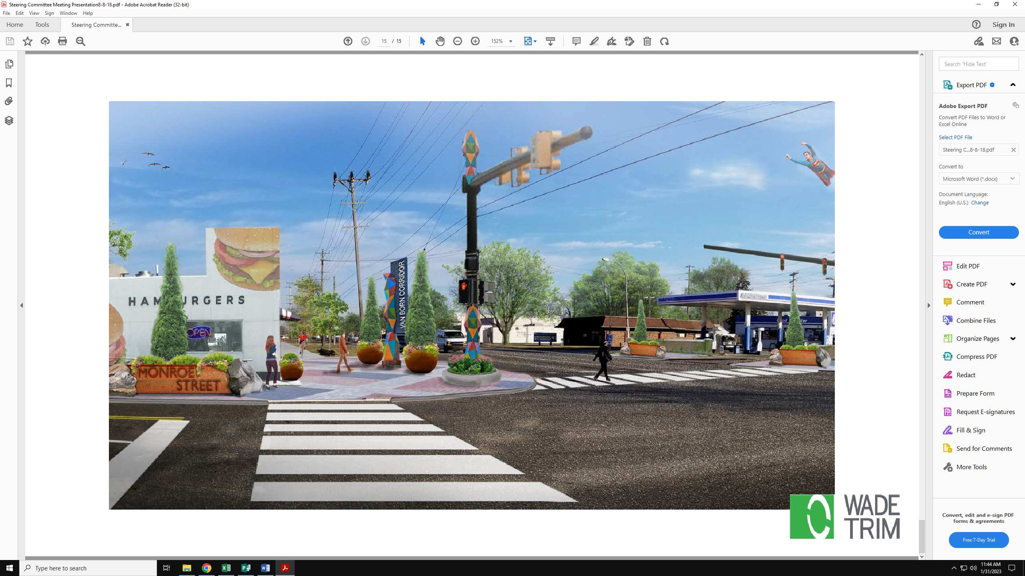
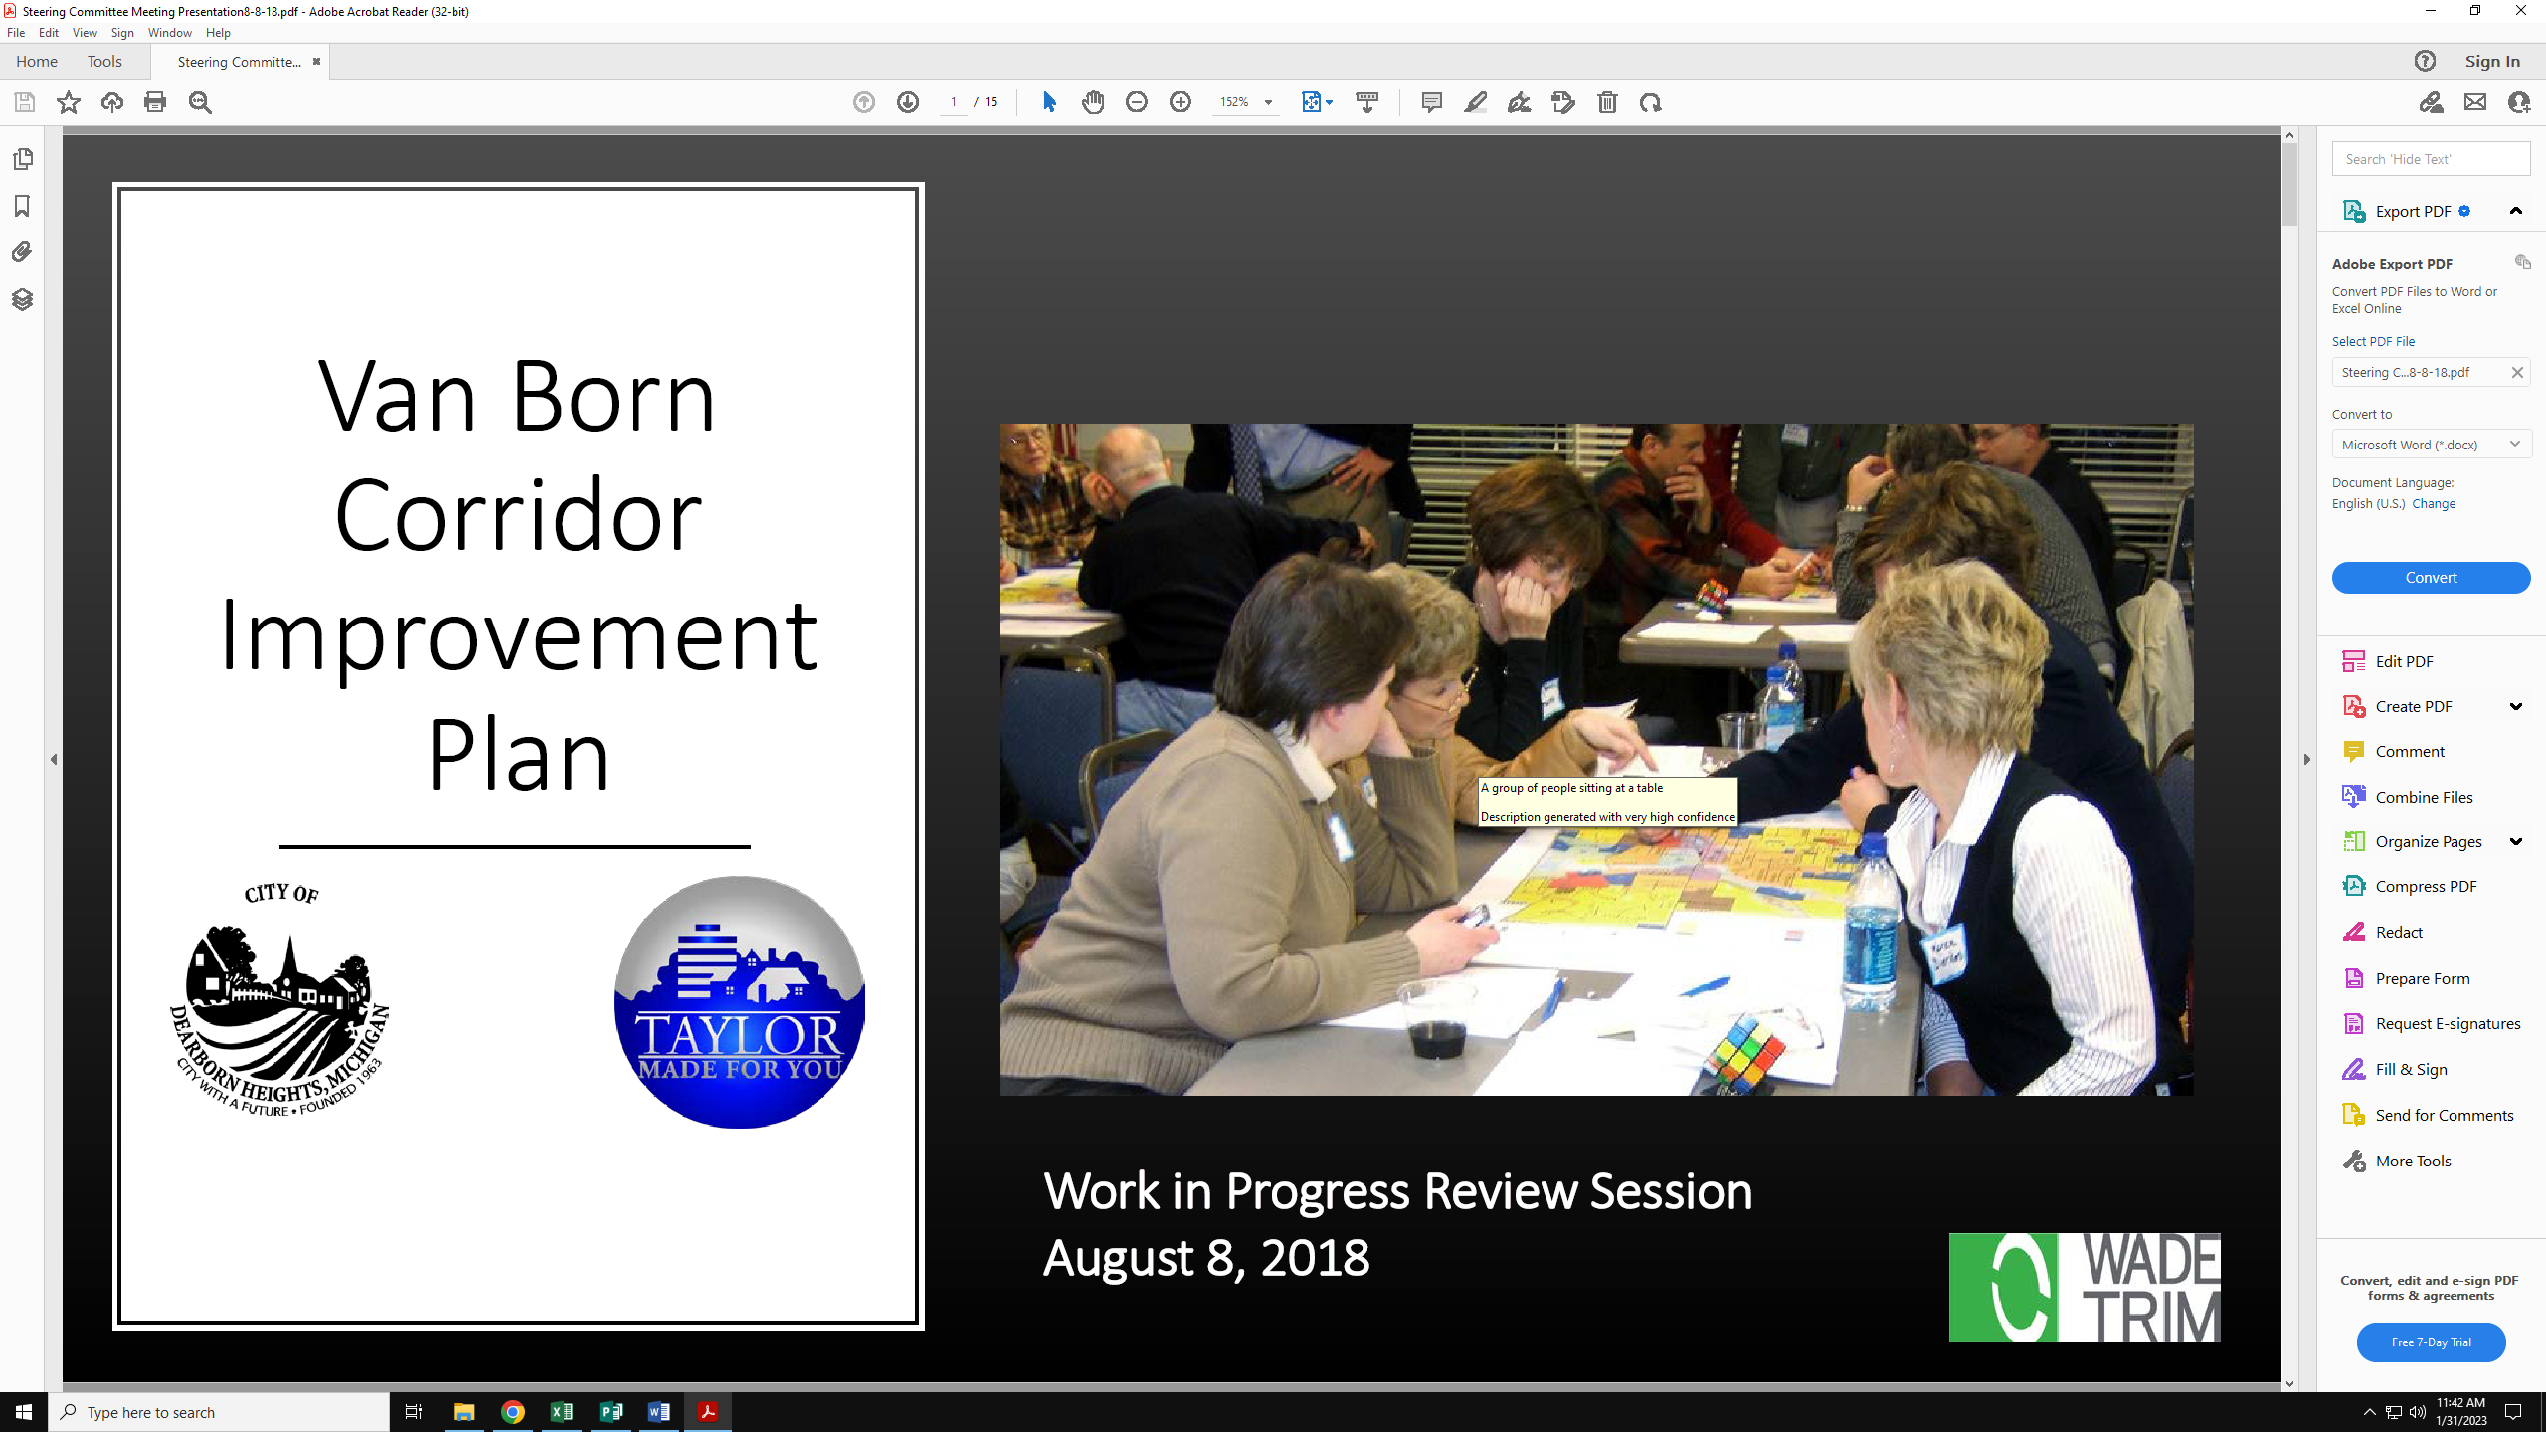
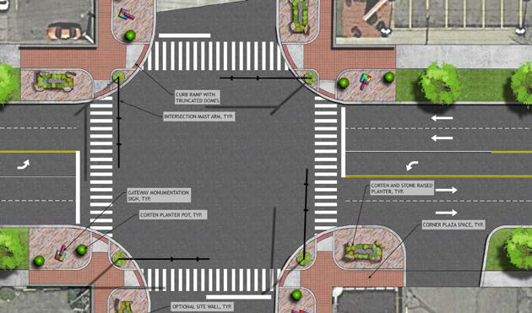

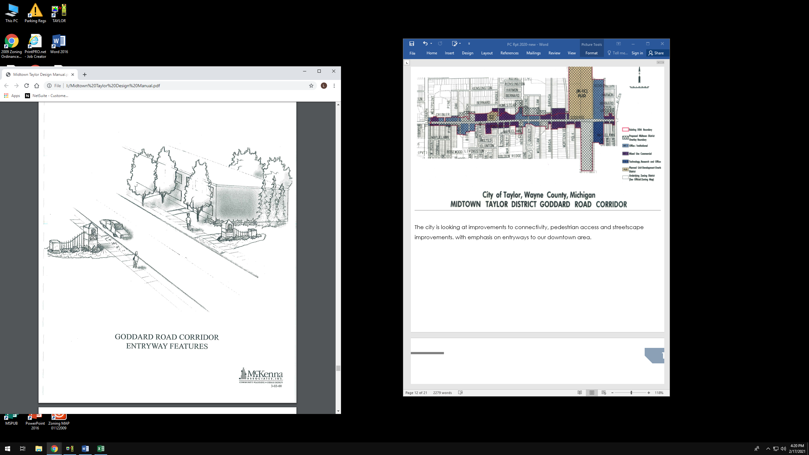
The city is looking at improvements to connectivity, pedestrian access and streetscape improvements, with emphasis on the entryways to our downtown area.

RECOMMENDATIONS TO CITY COUNCIL
The Planning Department is continually reviewing the City’s Master Plan and Zoning Ordinance for revision and updates to our application procedure, website and ordinance requirements. The Planning Commission will bring forward recommended changes for the Council’s consideration, as needed or requested.
Together with the Planning Department, the Planning Commission will continue to support all efforts of Administration, all City Departments, Businesses and Residents, consistent with the current Master Plan and Ordinance, in order to encourage and develop quality new development and sustaining growth in our city.

SUMMARY
During the past year, over 231 new developments and businesses were processed through the Planning Department. Planning Commission reviewed over thirty-two (32) new development projects.
In addition to the reviews and recommendations to City Council. the Planning Commission also reviews and adopts the City’s annual CIP (Capital Improvements Plan). This plan is utilized by all departments in the city for the planning, funding and implementation of all new City improvements.
Taylor’s Planning Commission has held Special Study Sessions for the Van Born Overlay and continues to review the Zoning Ordinance for any possible conflicts or needed revision. Five properties were rezoned last year in order to accommodate new development. Amendment to the Zoning Ordinance is an on-going process, as the city changes, and the Planning Commission is constantly looking for needed revisions and amendments, to keep our ordinance current and to provide for a healthy, safe, family-friendly environment.
The City of Taylor Planning Commission is committed to striving for the best possible commercial, industrial and residential development which promotes quality of life, responsible growth for our city, and for the facilitation of the continued advancement and economic growth of our city.

